**Project Proposal**

**Problem Overview**

The proposed solution is a link to bring customers and workers together for a specific task. Users or customers can hire all the workers like Plumber, Carpenters, Interior Designers, Electricians, welders and equipment operators according to their needs. The workers can register through the application and can find a job. There is not any specific platform through which customers can hire workers for all sorts of day to day activities. Also, with the help of this platform people will find employment.

**Key Functionalities**

* Users/Customers
  + Login/signup
* Supplier
  + Create Suppliers
* Labour
  + Create labours

**Proposed Entities**

1. Users
   1. SSN
   2. Address
   3. Phone number
   4. Booking History
   5. Worker Details to hire
2. Supplier
   1. Username
   2. Create suppliers
   3. Receive work request
   4. Accept request
3. Labour
   1. Login
   2. Update his/her data
   3. Create Labours
   4. Receive request from the supplier

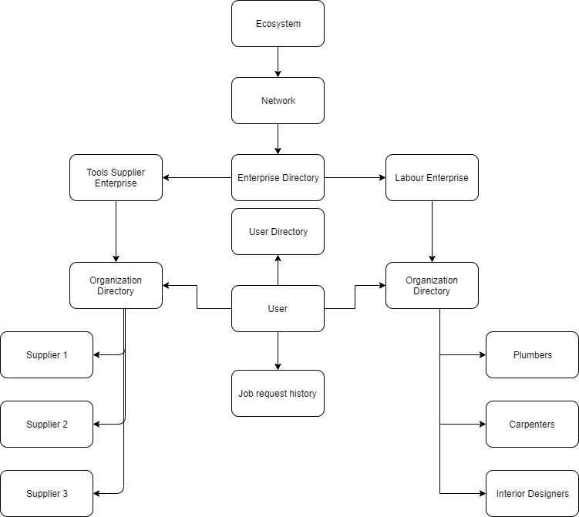

**Ecosystem Diagram**